A new

MAO PHEAKTRA

DIGITAL MARKETING

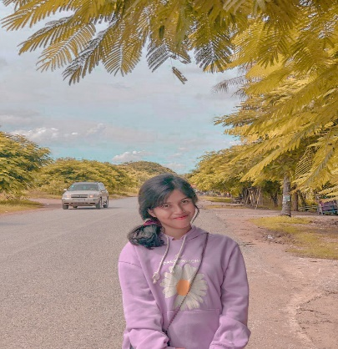

* **Senior Digital Marketing**

**September 2023-Present**

* Professional class in digital marketing
* Creative idea for digital marketing
* Organize of social media post editorial departemen.
* Handing social media campaign.

**Education of digital marketing**

Bachelor of digital marketing and business

**Bachelor of digital marketing**

Bachelor of digital marketing and business

**EDUCATION**

* **Junior Digital Marketing**

**June 2030, present**

* Manager oversees company digital marketing to more client in social media.
* Managing team to handing social media.
* Product marketing
* Increated client and customer.

**WORK EXPERIENCE**

Energetic digital Marketing with 5+ years of experience in of digital marketing company. Skills in data processing and documentation analysis. At Liceria & Co. helped to in crease work efficiency by 10% implementing a documentation workflow system.

**ABOUT ME**

**SKILLS**

* English
* French
* Spanish
* Korea

**LANGUAGE**

* Program
* Marketing Analysis
* Team Work
* Technology
* Marketing

**Phone**

+123-456-7890

## Email

[hello@reallygreatsite.com](mailto:hello@reallygreatsite.com)

## Address

Street 371, sorla, Phnom Penh

**CONTACT**